Press release Sulz am Neckar, Germany, February 2015

Gentle clamping

KIPP clamping lever with thrust pin

The new version of the KIPP clamping lever permits clamping on sensitive surfaces. A soft pin at the end of the thread ensures damage-free optimum clamping.

The "KIPP clamping lever with thrust pin" was developed to secure objects with a sensitive surface. This is done by a thrust pin at the end of the external thread. This first variation of the clamping lever is fitted with a brass pin. This material is softer than most materials and thus avoids scratches or damage to any components being clamped. This extension of our product line represents a gentle alternative, especially for applications on visible clamping points in plant and machine construction.

The standard version consists of a conventional KIPP handle (fibreglass reinforced plastic) and an external thread with brass thrust pin. The external threads are available ex-stock as black oxidised versions in 20 to 60 mm lengths and M5 to M10 thread sizes. Other variations will follow.

Special thust pin versions are available on request, such as a plastic pin or plastic ball. Thread lengths and clamp lever colours can be individually tailored to suit.

Characters including spaces:
Headline: 35 characters
Pre-head: 15 characters
Text: 1,121 characters
Total: 1,171 characters

HEINRICH KIPP WERK KG
Stefanie Beck, Marketing
Heubergstrasse 2
72172 Sulz am Neckar, Germany

Telephone: +49(0)7454 793-30
e-mail: s.beck@kipp.com

Additional information and press photos
See www.kipp.com, Region: Germany, Category: News/Newsroom

Photos

Image text:
The KIPP clamping lever with thrust pin at the end of the operating part ensures optimum damage-free clamping. Photo: KIPP

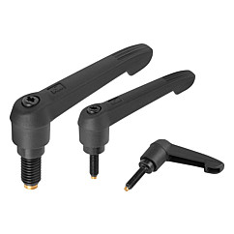  Image copyright: Released for licence and royalty-free publication in speciality media.  With the request to cite the source and receipt. | Image file:  KIPP clamping lever with thrust pin.jpg

