Press release Sulz am Neckar, Germany, December 2014

Wear resistant, precise and robust

KIPP metal scales for durabilty

Deep laser engraved metal scales have long been one of the most popular product groups from the HEINRICH KIPP WERK. The wear-resistant scaling sets the highest standards in terms of durability and reliability. A special version combines a screw hole and self-adhesive backing to guarantee high stability and resistance to dirt.

Metallic scales are used in machine, plant and fixture construction. They are used wherever (pre)settings are required. Thanks to the deep laser engraving they are extremely wear-resistant and durable by regular cleaning.

This product group has become extremely diverse due to regular product expansion. HEINRICH KIPP WERK supplies metal scales in black anodized aluminium and stainless steel, with zero marks and vernier scale from stock. The vernier scales have an accuracy of up to 0.01 mm.

Apart from the standard versions of metal scales, KIPP also provides customer specific versions. For example: A combination of self-adhesive backing and screw hole enables the to give highest levels of stability and resistance to dirt. On request the metal scales are also available in special lengths, the scales can also be custom-defined.

Characters with space:
Headline: 31 characters
Pre-head: 35 characters
Text: 1.161 characters
Total: 1.227 characters

HEINRICH KIPP WERK KG
Stefanie Beck, Marketing
Heubergstrasse 2
72172 Sulz am Neckar, Germany

Telephone: +49 (0)7454 793-30
e-mail: s.beck@kipp.com

Additional information and press photos
See www.kipp.com, Region: Germany, Category: News/Newsroom

Photos

Image text:
Metal scales are available in aluminium or stainless steel, self-adhesive or with holes. Photo: KIPP

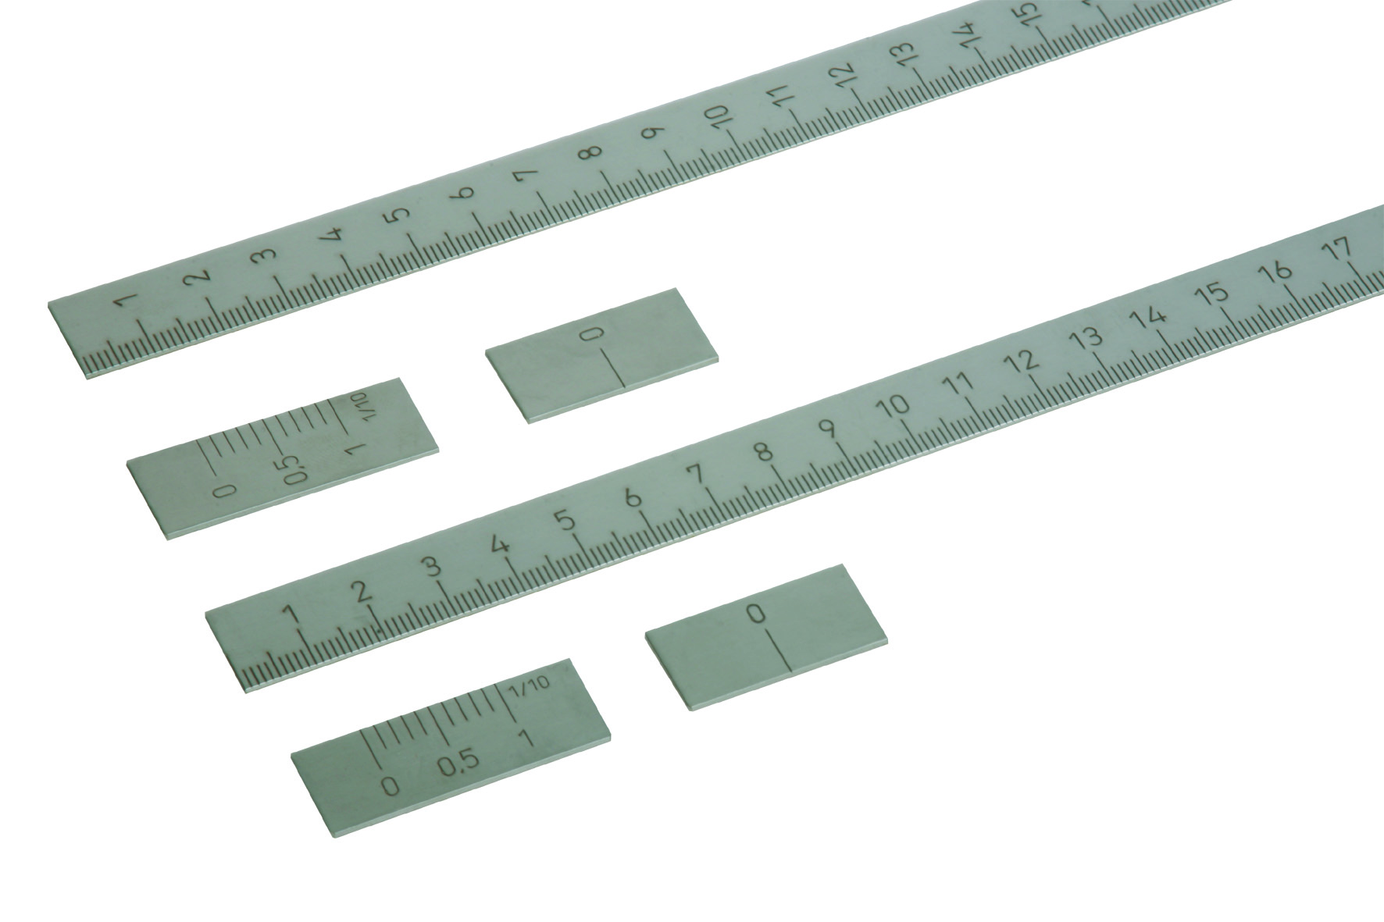

Image file:
KIPP_Maßstäbe_Edelstahl_K0759.jpg

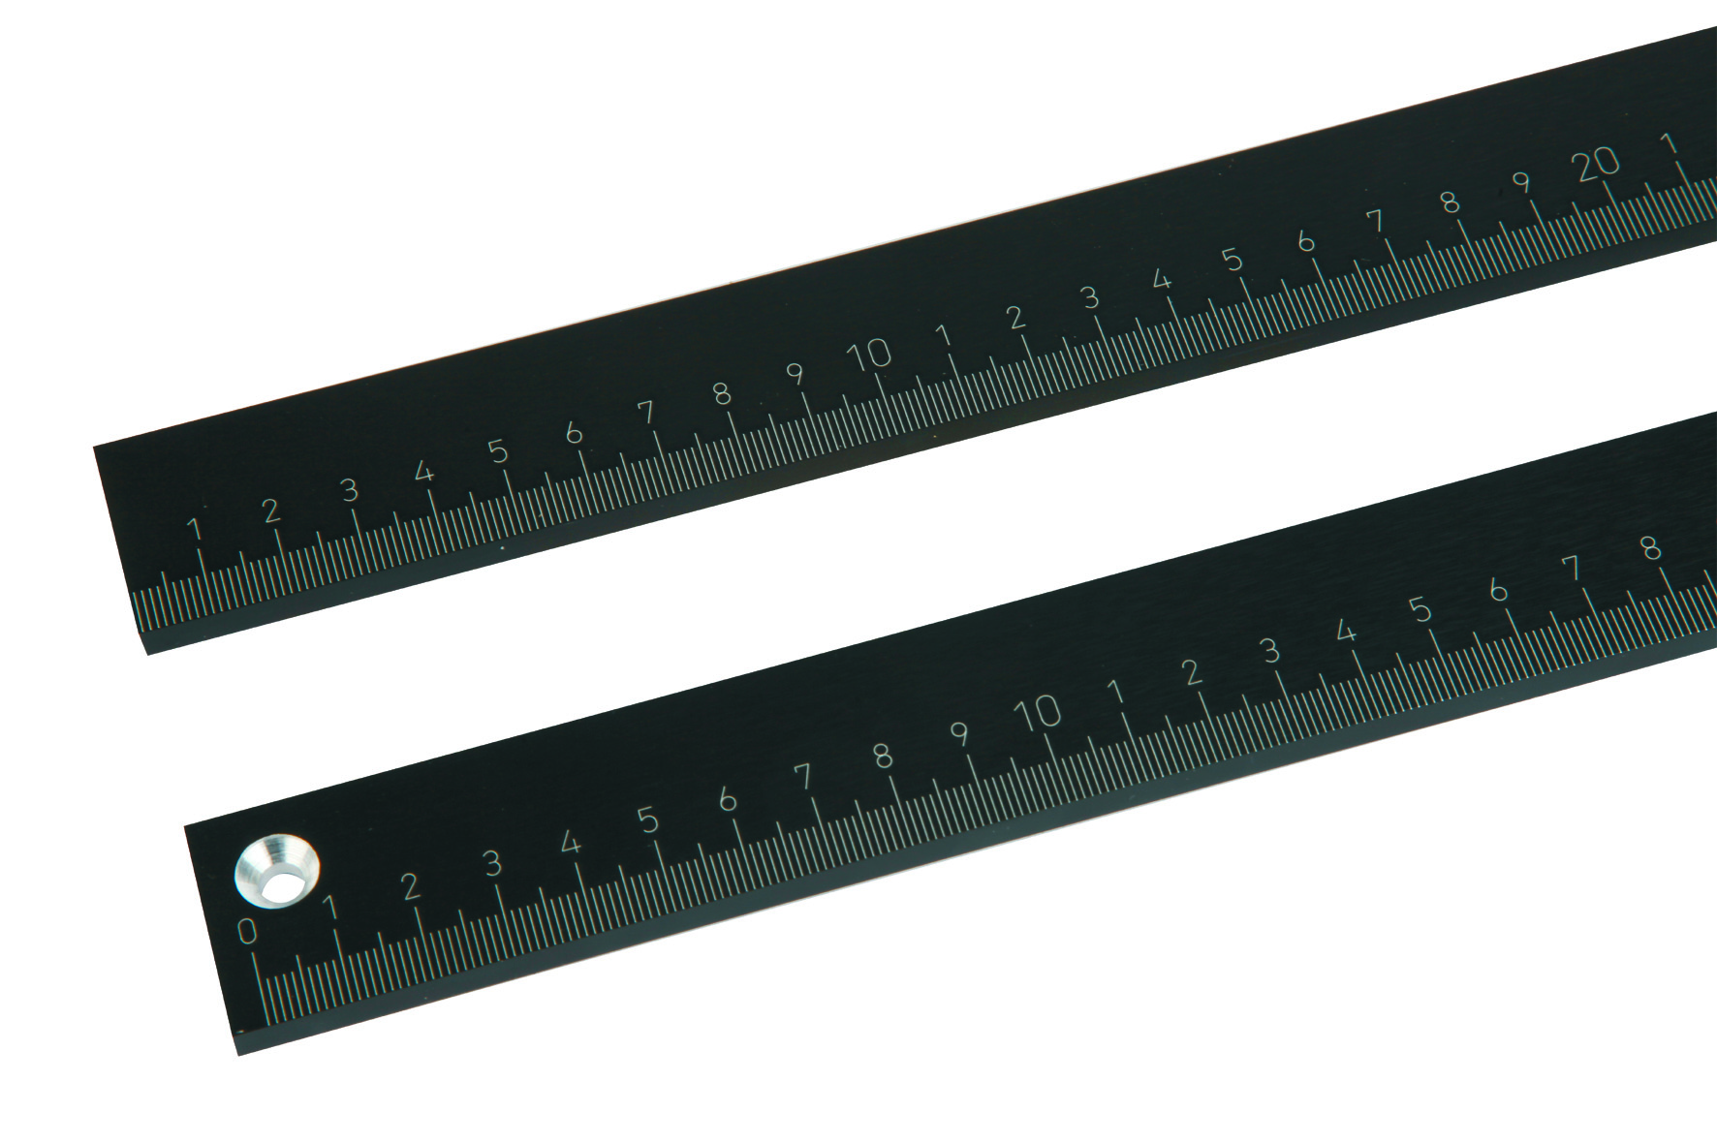
Image file:
KIPP_Maßstäbe_Aluminium_K0758.jpg

Image copyright: Released for licence and royalty-free publication in speciality media.
With the request to cite the source and receipt.

