Sulz am Neckar, August 2021

Indexing and clamping grip:
Combined functions in one product

Two becomes one: HEINRICH KIPP WERK has launched a solution that takes over the tasks of both indexing plungers and star grips. With these users can position, secure and clamp diverse adjustment elements with just one product. The new indexing and clamping grip is also available as an option with an optical locked indicator, providing additional safety in use.

Customers can feel confident with the new Indexing and clamping grip: Indexing is effected positively with the pin and clamping is achieved frictionally via the end face of the sleeve. Twisting the grip in the retracted position holds the indexing pin in the retracted position. By the Model with optical locked indicator a protruding signal button means that the indexing pin is not completely extended.

The device is suitable for the manual operation of assemblies, aggregates, machines and fixtures, but can also be used on e.g. sports equipment. The star grip ensures comfortable and ergonomic operation. The user simply pulls the indexing and clamping grip which, when released locks and fixates the support arm at the desired height. The optical locked indicator is an ideal choice especially for the height adjustment of monitors: the user can see at first glance whether the pin is engaged or not. Otherwise, the monitor could slide down unintentionally and change its position.

Indexing and clamping grips are made of black thermoplastic; the red signal button which is made of the same material stands out visually. Eight different sizes and versions are available. The diameter of the stainless steel indexing pin varies between 4–8 mm, while the steel threaded sleeve is available in the sizes M8–M16 and have standard or fine threads.

(Characters including spaces: 1,770)

Image overview:

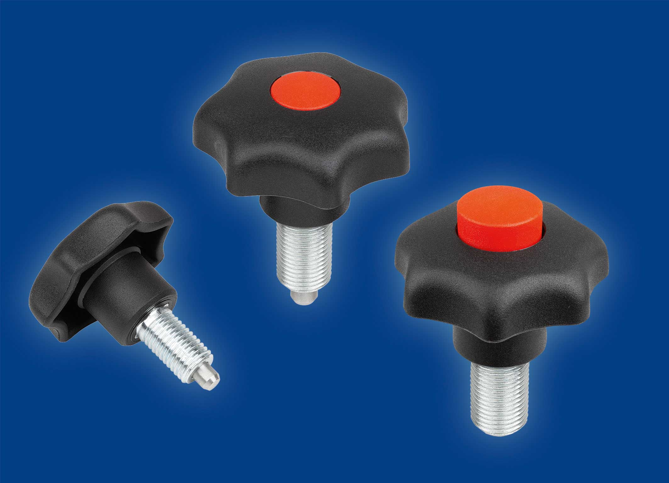
The new indexing and clamping grip from KIPP combines the functions of an indexing plunger and star grip.

HEINRICH KIPP WERK GmbH & Co. KG
Stefanie Beck, Marketing
Heubergstrasse 2
72172 Sulz am Neckar

Telephone: +49 7454 793-30
Email: stefanie.beck@kipp.com

