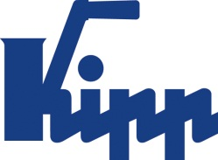

Press release Sulz am Neckar, Germany, May 2018

Accolade from FOCUS MONEY

KIPP is one of the best training organisations in Germany

According to a study by DEUTSCHLAND TEST and FOCUS MONEY, HEINRICH KIPP WERK counts among the best training organisations in Germany. The company directors, Heinrich Kipp and Nicolas Kipp welcome the positive results and look to the future: To meet the challenges ahead, it is now more important than ever to enthuse talented and motivated young people for an apprenticeship or duel course of study in the company.

HEINRICH KIPP WERK currently employs 50 trainees in 12 different training professions such as industrial mechanics, warehouse logistics specialists or technical product designers. KIPP also trains in commercial professions and enables a dual course of study. Overall, the trainee ratio is currently around 14%. "We have always attached great importance to in-house training and so, investing specifically in our future" explains Managing Director Heinrich Kipp. "It is very important for us to be convincing as an attractive training establishment, so that we can win the best trainees for our company. In general, we will be greatly expanding our training opportunities in the future", adds Managing Director Nicolas Kipp. A good example of this is the planned expansion of the companies apprentice workshop for the mechanical professions.

In the course of the study "Deutschlands beste Ausbildungsbetriebe" (Germany's best training companies) DEUTSCHLAND TEST and FOCUS MONEY consulted the training staff of 20,000 companies with the highest employee count from more than 90 branches. Among other things, information on training success or the trainee ratio was used to assess the quality of training. Of the 20,000 companies surveyed, 745 received the award.

Characters including spaces:
Headline: 55 characters
Pre-head: 28 characters
Text: 1,691 characters
Total: 1,774 characters

HEINRICH KIPP WERK KG
Stefanie Beck, Marketing
Heubergstrasse 2
72172 Sulz am Neckar, Germany
Telephone: +49(0)7454 793-30
Email: stefanie.beck@kipp.com

Additional information and press photos
See www.kipp.com, Region: Germany, Category: News / Press area

Photos

KIPP counts amongst the best training organisations in Germany
Photo KIPP
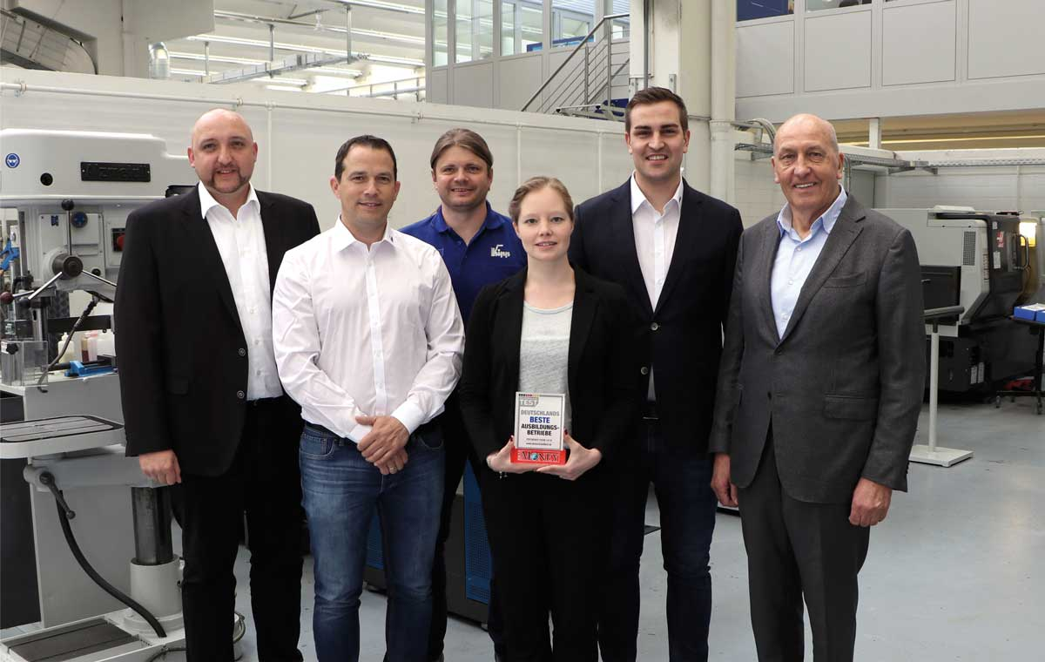
Image data:
KIPP_FOCUS_Beste Ausbildungsbetriebe_2018_300dpi.jpg

KIPP receives the award "Germany's best training company"
Photo KIPP
Image data:
KIPP_FOCUS_Beste Ausbildungsbetriebe_Award_2018_300dpi.jpg

Image copyright: Released for licence-free and royalty-free publication in speciality media.
Please cite the source and submit a reference.

